**Princes Park Health Centre**



**FREQUENTLY ASKED QUESTIONS**

**ACCURX TOTAL TRIAGE** LAUNCHING 18 NOVEMBER 2024

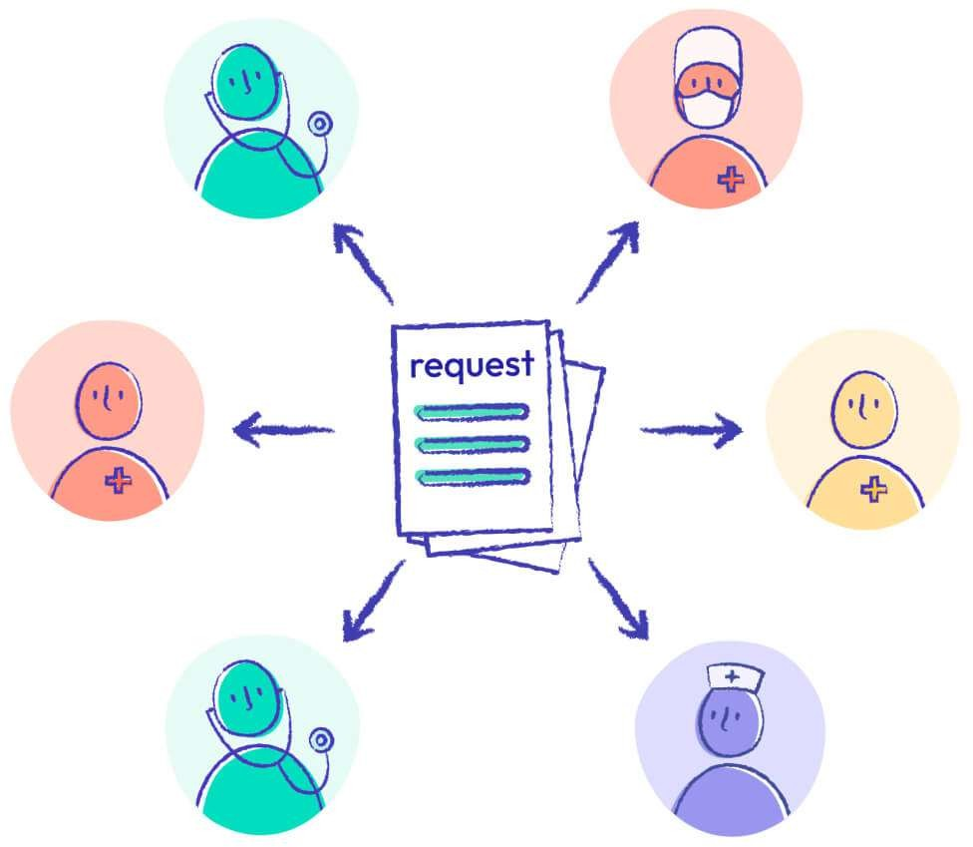

Princes Park Health Centre

Wartling Road

Eastbourne

BN22 7PG



# FREQUENTLY ASKED QUESTIONS

**New appointment system – Total Triage Accurx**

**On 18 November 2024** we are changing the way appointments can be booked. We have become increasingly aware that the existing system, with the 8.30 a.m. ‘rush to book’ an appointment is very stressful for both our patients and our staff. This increasing demand for Healthcare services is reflected nationally. We have carried out extensive research and we believe that the new system we are introducing will be more efficient, quicker and easier to use for everyone. This said, we recognise that many of you will be concerned about how this new system will affect you and your family. We have compiled the following **Frequently Asked Questions** which we hope will help you understand how it will operate.

# How do I book an appointment?

The triage system will operate from 8.30 a.m. every working day (Monday to Friday excluding bank holidays). Patients will be asked to submit their medical and admin requests via a short online form. The medical form contains five questions about your medical issue. You will be able to upload photos if you wish on the form. You can access the form from a smart mobile phone or via our website [click here for practice website](https://www.princesparkhealthcentre.co.uk/) where you will find it on the home screen. Click on the button which says ‘**Appointments and online requests**.’ It is designed to be easy and quick to complete. At the end of this document is a copy of the form for you to see. You will receive an acknowledgement notice once you submit your form. You can also opt to have a copy of your request sent to you.

Patients who have already given their mobile numbers or email addresses to the surgeries will, where possible, be contacted prior to the launch of the new system with a link to the form.

# What is the link to submit a medical / admin request?

As stated above, this can be found on the homepage of our Practice website [click here for practice website](https://www.princesparkhealthcentre.co.uk/) where you will find it on the home screen. Click on the button which says ‘**Appointments and online requests**.’

# What if I don’t have a smart mobile phone or access to a computer or have special communication needs?

You can still call the practice on **01323 744644** and a receptionist will fill in the form for you. You can also visit the practice in person and a receptionist can submit the form on your behalf. The requests will be dealt with in exactly the same way regardless of how you have submitted the appointment as all requests will be reviewed by the appropriate team in the first instance.

# What happens once the form has been received at the surgery?

Every form received will be triaged (reviewed) by the triage team (which includes clinicians). The team will decide how best to proceed with your query. If your query is medical and the triage team feel an appointment is appropriate, this will be classified internally as Red – urgent, Amber - less urgent and Green – routine. Red appointments

will be allocated soonest, then Amber and then Green. The appointment will be booked in on the basis of clinical need, with the most appropriate person – a doctor, Physio, nurse, or, if simply an administration matter such as querying at what stage a referral is, by the admin team.

Patients will not be given an appointment at the time their form is submitted but instead someone from the surgery will make contact once the request has been reviewed.

You will be contacted within two working days of submitting a medical request but obviously urgent cases will be dealt with as a priority as is the case now. It is anticipated that most, if not all, requests, will be reviewed on the day they are received, but please remember if your concerns are very urgent you should ring 111 for advice or go straight to A&E if you are very unwell and require immediate treatment. Your admin request will be dealt with as soon as possible by the administration team.

# What is Accurx?

Accurx is the name of the software we are using to support our total triage model. Accurx is an approved NHS supplier.

# What about the security of my medical records with Accurx?

We recognise that you might be worried about the security of your medical records with the new system but we can reassure you there is no need to worry. Your personal medical details will be as secure as they are now.

Accurx transmits and stores data in encrypted form. This means nobody else can read it without the right credentials. When stored, your data is encrypted in an extremely secure UK-based Microsoft Azure data centre.

Accurx meets the highest standards of safety and security as set by NHS bodies and the government. Accurx goes through assurance processes for these and regularly get outside independent experts to check its systems are secure. You can see a list of its security credentials in their [Resource Centre](https://support.accurx.com/en/articles/4970829-patient-triage-resource-centre)

There is no Artificial Intelligence (AI) used by the Accurx system.

# What happens if all the appointments are booked for the day?

When you click on the link to submit a medical request, if all of the appointments for the day have been utilised, a note will be displayed advising that we have reached our safe working limits for the day and therefore patients will be advised to contact 111, as they are now, or, if the patient feels that their query really cannot wait, they are able to call the surgery and talk to the receptionist. You may wish to look again online or call back later to see if the form is available again. As the day progresses more appointments may become available; this situation could arise where not all requests received require an appointment, therefore freeing up capacity.

It will be possible to submit admin requests outside of regular working hours. However, these are unlikely to be responded to outside of working hours. If a patient uses the admin request function for something which should actually be a medical request, the

patient will be asked to resubmit their information using the medical form in order that the request can be triaged in the correct manner.

# Can I submit the medical form before 8.30 a.m.?

It is not possible to have access to the medical form before 8.30 a.m. each day. You could, however, draft your text in advance and then copy this over to the relevant questions once the form is available if you wish to save time. Each question permits an answer with a maximum of 500 characters.

# Who will contact me?

You will be contacted (if necessary) by the most suitable person for your request. This will be by telephone, text or email.

# What if I need to get a prescription?

If you need to obtain your prescription or require a repeat prescription you should use the NHS App if possible as it is the quickest and most convenient method of managing repeat medication requests.

You can send your request through the App at any time of the day or night – no waiting for the practice to be open, no phone calls and no need for extra trips to the practice. Requests via the NHS App or NHS Portal can be processed in just a few seconds as it is directly linked to your records and has no room for error.

See the end of this document or for a ‘**How to Guide’** on how to use the NHS App.

It will still be possible to request repeat medication by calling the practice on 01323 744644, between 8.30am and 6pm Monday to Friday.

You are also able to request prescriptions by posting your repeat slip at the front of the surgeries in the dedicated prescriptions box – please tick the items you require.

# What if my request is routine or not urgent?

You will still be able to submit your request using the medical request form as long as we have capacity. It is possible that you may be able to seek assistance from a pharmacist for advice as they are now able to prescribe antibiotics and other drugs (under the new NHS Pharmacy First scheme), especially for the treatment of seven conditions: Ear ache, Impetigo (a bacterial skin infection), infected insect bites, shingles, sinusitis, sore throat and uncomplicated urinary tract infections in women. Not all cases of the above conditions can be dealt with by pharmacies. You can check whether it is likely that a pharmacist can help you by clicking on the below link. <https://healthmedia.blog.gov.uk/2024/02/01/pharmacy-first-what-you-need-to-know/>

Pharmacists can also give advice on other medical ailments such as head lice, thrush, worms, sun burn, hayfever and allergies, indigestion remedies, etc. You are able to discuss your symptoms with a pharmacist.

We would not usually expect to prescribe the following items as these are usually readily available from pharmacies.

* + Cream/medication for thrush
  + Cough and colds medication
  + Common pain killers such as paracetamol and ibuprofen
  + Head lice/worms treatment
  + Hayfever and allergy treatment
  + After sun/sunburn
  + Calpol/ibuprofen for children
  + Indigestion remedies
  + Moisturisers

# I have listed the best times to contact me on the medical form, will you be able to keep to these?

We will do our best to contact you at your preferred time, however, we cannot guarantee to do this in all circumstances.

# How do I book in for a blood test?

This is considered a medical request and you should complete a medical request form. You will then be contacted by someone at the surgery as appropriate.

# How do I get my test results?

Most test results are available on the NHS App. You are likely to be directed to use the NHS App to see your test results. If you require further information about your results, please submit your questions using the admin form.

The surgeries do not have access to results of MRI/CT scans unless someone from the hospital where these tests were conducted writes to us. You will need to contact the relevant hospital or clinic you were referred for the scan to obtain your results.

Some x-ray results do come back to the surgeries, and you can request these results by submitting an admin request form.

# What if I have a condition which requires regular or long-term monitoring?

If you have a condition which requires long-term monitoring, with perhaps six-monthly blood tests for instance, you can request appointments for these on the admin form.

# How can I book an appointment with a nurse or HCA for a dressing or chronic disease review?

Please submit your request using the admin form advising what you need.

# What if I need to cancel an appointment?

You will need to call the surgery on 01323 744644 and inform the reception team. It is **very important** that you do this as it will allow that appointment to be re-allocated.

# How will you be communicating the change to the way of working for all patients?

Comprehensive information regarding the changes will be published on our Facebook practice page and practice website. Ahead of the go-live date of 18th November we will also be sending electronic messages to all those patients whom we have mobile telephone numbers for, advising them of the change.

We are also displaying various posters around all surgery sites including our reception screens with information and also our phone message when calling the surgery will be updated announcing the change.

Patients who visit us in person on or after 18 November 2024 will be advised that their request will need to be submitted via either a medical or admin form (either completed by themselves or a receptionist on their behalf).

# Can you summarise whether I need to submit a medical or admin query?

Below is a non-exhaustive summary of whether you would need to complete the medical or admin form on Accurx.

|  |  |
| --- | --- |
| **Medical Form** | **Admin Form** |
| Requiring a GP appointment | Where’s my referral? |
| Muscular skeletal issues | Fit note (unable to work certificate) |
| Help with mental health | Test results |
|  | Booking a nurse or HCA appointment |
|  | Medical insurance forms |
|  | Travel and life insurance forms |
|  | DVLA/ Blue badge applications |
|  | Booking vaccinations |
|  | Requiring a doctor’s letter |
|  | Travel vaccinations |

If a patient uses the admin request function for something which should actually be a medical request, the patient will be asked to resubmit their information using the medical form in order that the request can be triaged in the correct manner.

**HELPING US HELP YOU**

**We absolutely recognise that this will all be a very new, different way of contacting us. We are confident that once the new system is in place and working well it will provide you with a much more efficient and effective way of being able to get in touch with us.**

**Completing the form is the best way for our clinicians and staff to start your patient journey. The request form, designed by GPs, gathers the information needed for your care. It also allows us to make the most of our whole team and resources. Every patient will receive the same level of attention no matter how they contact us.**

**With more people using our website to complete a request our telephone lines will be less busy. This will improve access to those who need to contact us by phone or with an urgent matter. GP appointment availability should increase as we will be able to make better informed decisions about how best to manage a patient need.**

**We anticipate that it will take a month or so for the new system to ‘bed down’ and we would ask for your support while we all get used to this new way of working.**

***QUESTIONS WHEN SUBMITTING A MEDICAL REQUEST***

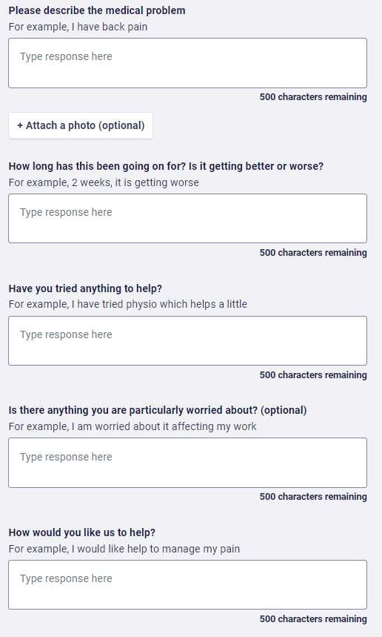

HOW TO ORDER PRESCRIPTIONS THROUGH THE NHS APP

**Step 1**- Download the NHS App

**Step 2**- Create login

**Step 3**- Under services, select ‘Request repeat prescriptions’. Your preferred pharmacy, may be displayed at this point, please check these details are correct before proceeding.

**Step 4**- Your existing medicines available for request will be listed. Select the medicines you want to request.

***NB. You are only able to order repeat prescriptions. Non-repeat prescriptions are one- off medicines you may have ordered before. You will need to submit a medical request form to order non-repeat prescription, as this service is unavailable through the NHS App***

**Step 5**- If needed, there is a free text box to add a note for your GP. If you need to make any changes, select the 'Back' option to return to the previous screen.

**Step 6**- Your prescription request is confirmed and will now be seen by our team who will be able to review your request. Once the prescription is approved it will show as issued on your order summary screen and will be sent through to your nominated pharmacy. Your pharmacy will advise when your prescription is ready to collect - contact them directly with any queries. Your prescription will usually be ready for collection by the fifth working day if not before.